**Sentinel Y3a G1-10mm by Peter F. Davis (257)**

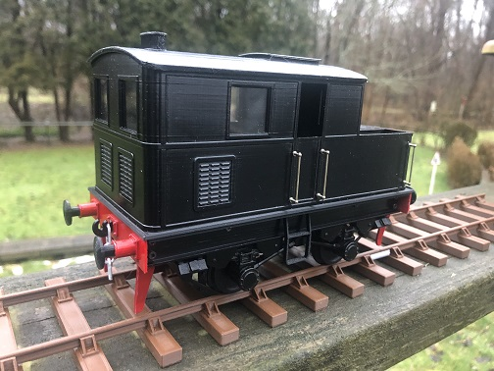

**I chose 10mm scale for this project and planning to make it in G3 13.5mm scale also. This time printing with an Elegoo Neptune 3 pro, .4mm nozzle, and PLA+ filament. Four AA batteries power the N-20 motor. Delrin sprockets and chain then deliver power to the axles. A DC motor control resides in the tender. On top the water tank is the forward/reverse switch, with the water filling tube utilized as the speed control knob.**

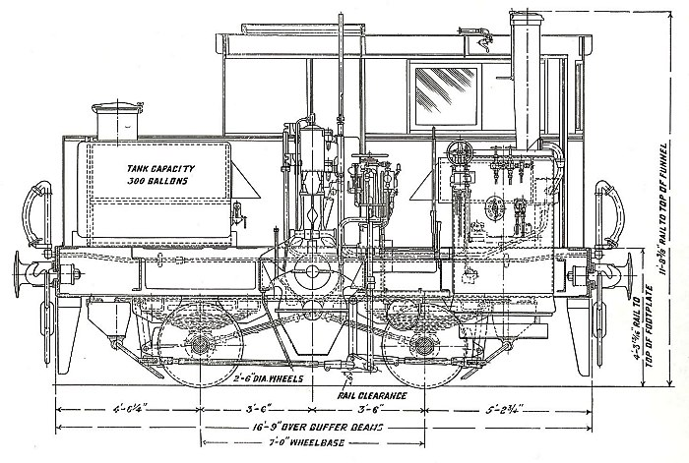

**I printed some of the parts rotated 45 degrees, so the top layer does not run diagonally. Such as buffer beam, water tank and side frames. I think this improves the finish.**

**I used Permatex low strength thread lock(purple) to hold the bearings in place. Otherwise no glue just screws.**

**Almost zero time was spent preping for paint. I know, it shows a bit. Tamiya Red gloss brushed for beams, Tamiya Black spray with a Tamiya clear semi gloss top coat.**

**Purchased parts:**

**Screws:**

**25 M2 x 8mm long Cap screws**

**8 M2 x 2mm long Set screws**

**Ground Rod: .125 Ground steel rod. For axles and Jack shaft.**

**2 .125 dia x 62mm long Axle**

**1 .125 dia x 40mm long Jack shaft**

**K&S Brass tube:**

**4 1/8 ID x 5/32 OD x 5mm Long for axle bearings**

**4 1/32” thick washers for thrust bearings. Loose fit on axles.**

**1 1/8 ID x 5/32 OD x 15.5mm Long for Jack shaft bearings**

**1 3mm ID* x 4mm OD x 8.5mm Long for motor to sprocket bushing .**

**\*I turned the OD down to fit the .125” sprocket bore in a small lathe with a 3mm piece of ground steel rod in the bore. As the bushing wall is only .003”, this keeps bore to size.**

**Window glazing: .5mm clear plastic.**

**Handrail Knobs:**

**I happened to have these on hand and were threaded. This was ideal. I believe I bought these from LocoSteam. I have some from Walsall but these are not threaded.**

**Manufacturer and Suppliers for Delrin Chain and sprockets:**

**USA, Serv-O-Link,** [**https://www.servolink.com/sprocks.htm**](https://www.servolink.com/sprocks.htm)

**USA, MicroMark,** [**https://www.micromark.com/**](https://www.micromark.com/)

**UK, try searching for delrin chain & sprockets or serv-o-link suppliers**.

**Chain: 1’ + one link. ( I purched from 2 suppliers and got a bit extra each time)**

**Sprocket:**

**1 9t 1/8 bore**

**1 15t 1/8 bore**

**2 10t 1/8 bore**

**2 16t 1/8 bore**

**The manufacturer recommends press fit for these sprockets. I found this was not enough and added set screws to assist holding them in place.**

**STL for drill jig and tap guide included.**

**Motor: N-20 300 RPM 6V**

**Switch: Mini rocker switch DPDT**

**Speed controller: “Wayintop” low voltage speed controller (There are other brands that look to be the same and may very well work. As long curcuit board is 32mm square like the Wayintop.)**

**Battery case: AA 4 aside**

**You can print and assemble the model without the motor and sprockets and controls, adding them later if you like. You willl need 40 mm long axles sleeves and the water tank top with filler. I will include these STLs.**

**Peter F Davis**

**January 2024**